The sturgeon may hold the key
By Stephen Uhler, OBSERVER MULTIMEDIA JOURNALIST
Thursday, August 23, 2012 11:51:35 EDT AM
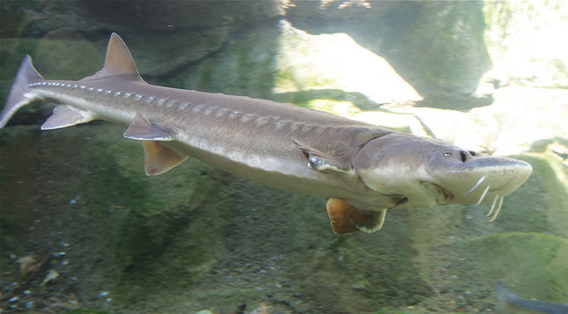

The health of the river sturgeon may be the deciding factor in the future of Xeneca’s plan to build a dam on the Petawawa River.

PETAWAWA – Approvals for the controversial Petawawa River hydropower project may hinge on how well a sturgeon navigates around a weir.
As part of the environmental assessment, Xeneca Power Development has to prove to numerous federal and provincial regulators that its project will not interfere with the spawning migration of Ottawa River walleye and river sturgeon, besides not obstructing river navigation or creating hazardous conditions to swimmers.
But it is the well-being of the fish making the Petawawa River home which is paramount to regulators before they give the green light to the power project.
Kristi Beatty, biologist and project manager with the Ontario Resources Management Group, a Pembroke-based consulting firm contracted by Xeneca, said it is mandatory the company provide a way for fish to be able to move up and down the river unimpeded, and if this cannot be done, the project wouldn’t get approved.
Working with experts in the field, a fish passageway has been designed which should do the trick, and be as natural as possible, setting up a series of ramps and boulders to bring fish up a low elevation change over a longer distance, something they should be able to surmount.
This is a big change from the way passageways are usually done, tending to be constructed out of metal or concrete, and feature a series of sharp curves to supposedly help fish work their way over obstacles.
The key to this, Ms. Beatty explained, is designing a fish passageway a sturgeon can get through. First, the fish is one of the species which needs to be able to use the channel, and second, if sturgeon can get through it, any fish species can.
“A lot of thought has gone into this,” she said.
One potential pitfall is the minimum flow rate through the fish channel that agencies like Ministry of Natural Resources and the federal Department of Fisheries and Oceans would like to see. This number hasn’t been set yet, and is one of those items Xeneca’s fish passageway model must be able to handle, whatever it turns out to be.
On top of this, the DFO mandates a certain percentage of success for fish getting through these passageways. Depending on species, this could range to just below 50 out of 100 fish making it through unharmed.
Still, Ms. Beatty is confident the design will do the job of diverting fish safely around the weir.
Xeneca hosted the last of a series of public information meetings at the Petawawa Civic Centre on Wednesday, another step towards finalizing its class environmental assessment report.
This report is to be wrapped up by the end of the year. Once it is submitted, the public and stakeholders still have 30 days to comment or point out areas it may have overlooked, which would then have to be addressed in order to finish off the document.
The company is hoping it can get approval by the first quarter of 2013, so it can proceed with making the project a reality.
Vanesa Enskaitis, with Xeneca’s stakeholder relations, said under an agreement with the Ontario Power Authority, the station must be commissioned by October 2015 as the province plans to replace coal fire plants with renewable energy generators.
This includes the 24 months required to construct the facility.
Construction of a “run of river” type complex at the Railroad Rapids just west of the town is scheduled to begin in the fall of 2013 if the project is approved by provincial and federal government oversight agencies.
The project will see Xeneca install a low profile weir across the river. The structure will not store water or change the natural river flows upstream of an intake channel situated above the rapids at the former Canadian Pacific Railway bridge. Water will run into a powerhouse outflow located west of the the Petawawa Bridge.
Petawawa Mayor Bob Sweet, who with members of council attended the meeting, along with a steady crowd of concerned and interested citizens, said this has come a long way since it was first presented to council seven years ago.
“Council remains adamant the integrity of this river cannot be affected by this project,” he said, which is why they insisted no concrete be used in the construction of the weir.
There isn’t a lot of political clout they can bring to bear on the plan, as council can‘t reject it outright because of the Green Energy Act, Mayor Sweet said, and they have no planning authority either, as the generating plant will be on Department of National Defence property.
What councillors have been doing are passing along the concerns brought to them by their residents.
About half of the original plan has been scrapped, as the DND blocked plans to build a second station at Half Mile Rapids in the vicinity of Mountbatten Bridge in the CFB Petawawa training area. Base commander Lt.-Col. Chris Moyle had stated that discussions with Xeneca earlier this year led to the decision, noting that the project was incompatible with the military training being conducted on an ongoing basis.
The final EA document, once completed, will be made available to the public to review, with copies sent to facilities such as the Petawawa Public Library and the municipal office.
(With files from Sean Chase)
Stephen Uhler is a Daily Observer multimedia journalist
stephen.uhler@sunmedia.ca

