ALGONQUINS OF ONTARIO

Confederation Line’s Pimisi StationPainted Paddle Project

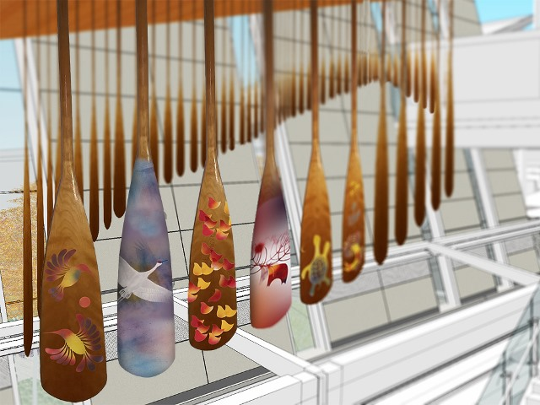

**Calling all Algonquin community members with a passion for art, craftworks and history**

Are you an Algonquin community member interested in cultural art, crafts or history? Do you have experience in drawing, painting, crafting (beadwork, leather, etc.), or other hobbies (woodwork, iron work, etc.)?

We are looking forinterested Algonquinsto showcase their talent and creativity by painting paddles for aninstallation that will be featured atConfederation Line’s Algonquin-themed PimisiStation in Ottawa.

**Public Art at Pimisi Station to Reflect and Celebrate Algonquin Culture**

Since the early inception of the East-West Light Rail Transit project (now known as the Confederation Line), the City of Ottawa has embraced the opportunity to recognize and celebrate the art, culture and heritage of the Algonquin people.

As the Confederation Line’s Algonquin-themed station, the design and artatPimisi Station will celebratethe historical and contemporary culture of the Algonquin people. Algonquin artists and artisans have been invited through a phased approach to submit their qualifications to be considered for the design of contemporary, innovative Algonquin public artworks at Pimisi Station. Unique to Pimisi Station is the strong focus on consultation and collaboration with the Algonquin communities throughout the entire artistic process.

Phase 1 of the Confederation Line Art Program launched in July 2012 withSobey Art Award winner Nadia Myre being selected as the Integrated Algonquin Artist at Pimisi Station. Nadia Myre is now nearing the completion of her Phase 1 designs for Pimisi Station, which were developed through close community engagement with the AOO and Algonquin communities, including participation in the annual Nation Gatherings and Talking Circles.

Phase 2 launched in June 2014, and internationally renowned Algonquin artist Simon Brascoupé was awarded the contract for the Non-Integrated Artwork at Pimisi Station.

One of the Phase 2 installations, titled *The Algonquin Canoe Paddle*will occupy a place of prominence in the station’s main hall. This installation will feature 100 paddles, each hand-painted by Algonquinsand arranged in the shape of a canoe. The piece is inspired by the important Algonquin teaching that it takes many people to paddle a canoe.

To support the project, Simon will mentor four Algonquin artists – Emily Brascoupé-Hoefler, Doreen Stevens, Sherry-Ann Rodgers and Sylvia Tennisco – who will in turn conduct paddle- painting workshops throughout Algonquin Traditional Territory. We are seekingseekinginterestedAlgonquin community membersof all ages – youth, adults and elders alike – to lend their talents to this exciting initiative.

The paddles paintedin these workshops will be featured in temporary art exhibits throughout Algonquin Traditional Territory before final installed at Pimisi Station.

**(IN THE FINALIZED BROCHURE, THE FOLLOWING PARTS WILL BE A TEAR AWAY SECTION)**

**CONFEDERATION LINE’S PIMISI STATION PAINTED PADDLE PROJECT**

Members of the Algonquins of Ontario – including youth, adults and elders – who have some experience in drawing, painting, crafting (beadwork, leather, etc.), or other hobbies (woodwork, iron work, etc.) are invited to participate in the Painted Paddle Project.

* One-day workshopswill be held throughout the Algonquin Territory for participants to create paddles for the Algonquin Canoe Paddle installation at Pimisi Station
* Professional Algonquin artists will be available at workshops to help participants with their paddle designs and painting
* All interested candidates must register for a workshop. Spaces are limited to 10-12 participants per workshop.

**June 25, 2016 – Pembroke (AOO Consultation Office)**

**July 16, 2016 – Ottawa (Venue TBD)**

**July 23, 2016 – Algonquin Park (Harkness Laboratory of Fisheries Research)**

**July 24, 2016 – Mattawa (Mattawa/North Bay Algonquin Office)**

**August 18, 2016 – Pikwakanagan (Venue TBD)**

**September 10, 2016 – Sharbot Lake (Cultural Center at White Lake)**

**For more information, please contact:**

Christine Luckasavitch

Economic Development Officer

Algonquins of Ontario Consultation Office  
31 Riverside Drive, Suite 101  
Pembroke, Ontario K8A 8R6

Telephone:(613) 735-3759 x 205

E-Mail: cluckasavitch@tanakiwin.com

**Algonquin Painted Paddle Project Registration Form**

Name:

Address:

Phone:

E-Mail Address:

Algonquin Community Affiliation:

I fit within the following categories:

|  |  |
| --- | --- |
| **Age:**   * Youth (12-18) * Adult (19-64) * Elder (65+) | **Experience (check one or more):**   * Drawing * Painting * Crafting (beadwork, leather, etc.), and * Hobbies (woodwork, iron work, etc.) * Other: ___________________________ |

Please provide a brief statement of your interest and background in Algonquin art and culture:

________________________________________________________________________________________________________________________________________________________________________________________________________________________________________________________________________________________________________________________

Please submit this registration form to the Algonquins of Ontario Consultation Office by any of the following methods no later than _________________:

**Christine Luckasavitch  
Algonquins of Ontario Consultation Office**

31 Riverside Drive, Suite 101

Pembroke, ON K8A 8R6

**Telephone:**

Toll Free: 1-855-735-3759

Local: 613-735-3759

**Fax:** 613-735-6307

**Email:** [cluckasavitch@tanakiwin.com](mailto:cluckasavitch@tanakiwin.com)

­­­­­­

**­­­­Algonquin Painted Paddle Project Work Sheet: To help spark your creativity**

*\*\*Please note that this section is for you to explore your own ideas and thinking. It is not a part of theapplication requirements.*

Algonquin Artist Simon Brascoupé, along with Emily Brascoupé-Hoefler, Doreen Stevens, Sherry-Ann Rodgers and Sylvia Tennisco,spoke with Algonquin community members and elders to gather insights on what imagery they would like to see on the paddles to reflect Algonquin art, heritage and culture.

They provided the following ideas:

**Algonquin culture:**

|  |  |
| --- | --- |
| * Clans and clan symbols * Algonquin values, such as the seven teachings * Plants * Animals | * Seasons, Stages of life * Food staples: berries, strawberries, wild rice, fish, fruit * Language |

**Algonquin Animals**

|  |  |  |
| --- | --- | --- |
| * Bear * Beaver * Blue Jay * Chickadee * Coyote * Crane * Deer * Duck | * Eagle * Eel * Fox * Frog * Hawk * Loon * Marten * Moose | * Muskrat * Otter * Porcupine * Rabbit * Skunk * Sturgeon * Turtle * Wolf |

**List your own ideas below:**

________________________________________________________________________________________________________________________________________________________________________________________________________________________________________________________________________________________________________________________

SKETCH YOUR IDEAS HERE:

